Circadian Clock Paper summary

# Goal: Summarize non-dimensionalization of SNF model and compare new and old manuscript

# Nondimensionalization

Original dimensional form of SNF

|  |
| --- |
|  |
|  |
|  |

and

*β*1 = *β*2 = *β*3 = *β*

|  |  |
| --- | --- |
| Parameter | non-dimensionalization |
| $$t$$ | $$t=β\hat{t}$$ |
| $$P$$ | $$P={\hat{P}}/{P^{*}}$$ |
| $$P_{\text{c}}$$ | $$P_{\text{c}}={α_{3}{\hat{P}}_{\text{c}}}/{βP^{*}}$$ |
| $$M$$ | $$M={{α_{2}α}_{3}\hat{M}}/{β^{2}P^{*}}$$ |
| $$A$$ | $$A=\hat{A}/P^{*}$$ |
| $$P^{*}$$ | $$P^{*}={{{α_{1}α}_{2}α}_{3}}/{β^{3}}$$ |

Variables denoted with ‘hat’ are dimensional with unit. Variables w/o ‘hat’ are dimensionless.

|  |
| --- |
| $$\frac{dM}{dt}=φ\frac{A_{free}}{A_{\text{T}}}-M$$ |
| $$\frac{dP_{\text{c}}}{dt}=M-P_{\text{c}}$$ |
| $$\frac{dP}{dt}=P_{\text{c}}-P$$ |

$$A_{\text{free}}=\frac{1}{2}\left[A_{\text{T}}-P-K_{\text{d}}+\sqrt{{\left(A_{\text{T}}-P-K_{\text{d}}\right)}^{2}+4{K_{\text{d}}A}_{\text{T}}}\right]$$

The non-dimensionalization method is the same as the previous manuscript in the supplemental information.

I also checked 2012 Kim Forger’s non-dimensionalization, which is the same as shown below.

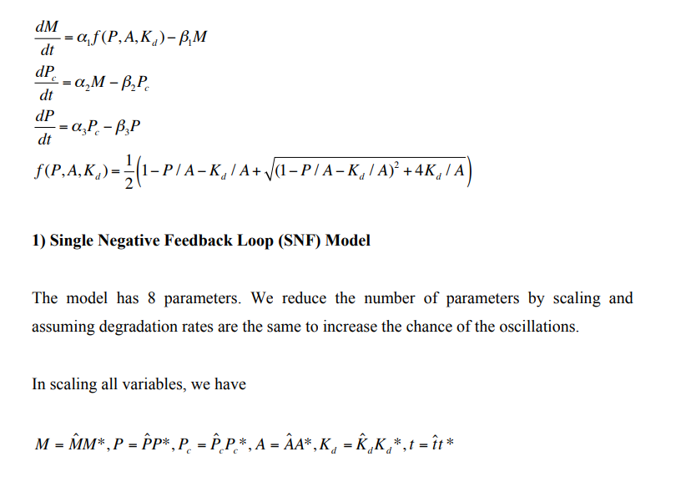

# Analytical analysis of the requirement of circadian rhythm

The major update of the manuscript is the analytical analysis of the requirement of parameter values.

To have a Hopf bifurcation, the condition must be met for a equality of $\tilde{φ}=φ/A_{\text{T}}$ and $\tilde{K}=K_{\text{d}}/A_{\text{T}}$.

$$\tilde{K}=\left(\frac{1+2F(\tilde{φ})}{2F(\tilde{φ})}\right)\left[1-\sqrt{1-{\left(\frac{2F(\tilde{φ})}{1+2F(\tilde{φ})}\right)}^{2}}\right]$$

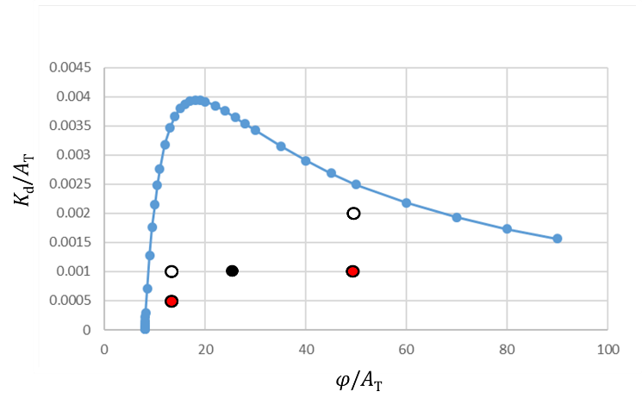

From the plot of the function, the black dot corresponding to homozygous WT is located. The value of 3 parameters would be *A*T = 1 (arbitrarily) and *K*d = 0.001, *φ* = 25

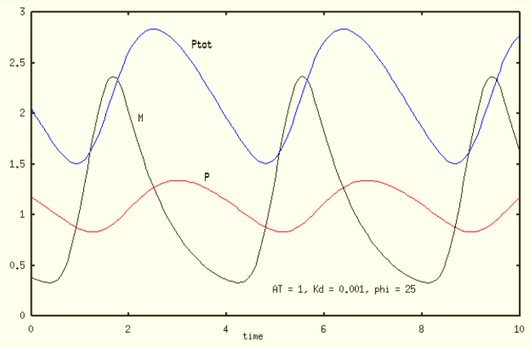

The dynamics of the model SNF 0L3 with these parameters shows circadian oscillation for P and Ptot, but the black curve corresponding to *PER* mRNA is not very sinusoidal.

# Problem of original SNF model:

It seems that *K*d/*A*T ≤ 0.001 is needed for circadian rhythm. With estimate of *Â*T ≈ 33 nM from experimental data, ${\hat{K}}_{\text{d}}<0.03 \text{nM}$. Together with new information, a new estimate is that $10 \text{nM < }{\hat{K}}_{\text{d}}<100 \text{nM}$, or in dimensionless terms, 0.3 < *K*d < 3.

Also, Per mRNA time trajectory becomes less sinusoidal if At becomes larger, which is not discussed in the previous manuscript.

# Test of the symmetry of a population of asymmetrical oscillation

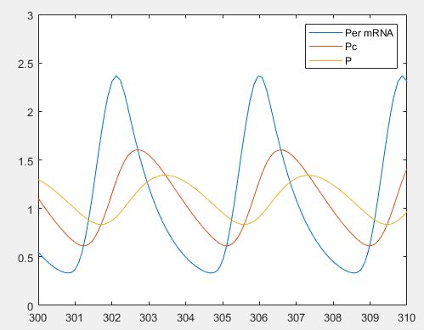

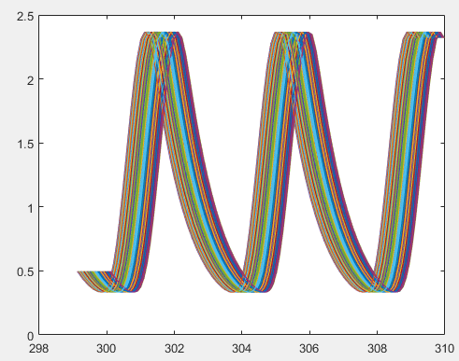

Random phase shift t~[0,1] hour

average

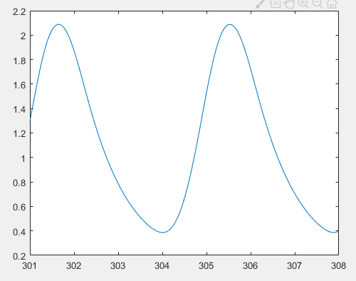

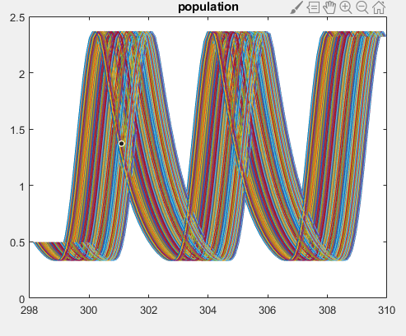

average

